2023
Winner: Harris Siderfin
Module: VP4120 (Visualising Peace)

Proposal:
Objective

To create innovative and engaging teaching tools to educate individuals on complex but critical topics such as climate change, war and peacebuilding. As part of the Visualising Peace project, I developed materials to help educate students about critical issues connected to peace. After researching the effectiveness of these resources, I hope to create similar materials to cover other topics, helping educate youth on critical issues to help build a more peaceful and understanding society.

Project introduction and background

As part of the Visualising Peace project, I researched methods of delivering peace education. "Peace education aspires to enable students to become responsible citizens...who can deconstruct the foundations of violence and take action to advance the prospects of peace." (Swiss Peace, 2021). To develop peace and prevent conflict, peace education must be delivered effectively.

I researched how education systems delivered peace education globally. I was surprised at the lack of resources and time dedicated to peace education within the UK. I decided to look at novel ways to deliver this type of education. I came across a company called Shujaaz based in Kenya, which utilises free comics to educate youth on topics such as terror groups, voting, sustainability and other critical topics. As part of the Visualising Peace project, I recorded a podcast with the CEO of Shujaaz, where I learned more about the company's work and how they create a positive impact in east Africa. Through interactive storytelling, Shujaaz is able to reach and educate 9.1 million 15–24-year-olds across East Africa, connecting them with the information, skills, and resources they need to make positive changes to their lives and communities. After speaking with Shujaaz, I felt I could fill a gap in the UK's education system and use comics to deliver peace education.

Why use comics?

Comics have been shown to communicate complex topics in an accessible way and have been used significantly in post-conflict societies such as Rwanda (Yamshon & Yamshont, 2006). They can be understood universally and offer a novel way to learn, hopefully encouraging students to engage with the topic. Comics also create an opportunity for soft-sell advertising - a more subtle form of advertising that aims to achieve a subconscious, indirect positive association with the product (Wagner, 2020). The attached resource attempts to create a more positive and sympathetic picture of migrants through this indirect positive association. Students interacting with the resource will care more about the character and actual migrants once they understand their plight.

Ian Harris (2004) defines five critical areas of peace education: international relations, human rights, international development, environmental education and conflict resolution. For my first comic, I wanted to focus on environmental education. The comic looked at the impact of climate change and forced migration in Bangladesh, a topic of increasing importance. The comic is titled "Āśā" and follows the story of a young girl in Bangladesh as she and her family are impacted by climate change.

Climate change continues to force millions of people to leave their homes and travel to new countries for refuge. Although migration is becoming an increasingly relevant topic within the UK, migrant hostility has increased within the UK's politics and public domain (Charlemagne, 2022; MacDougal, 2022; Merrick, 2022). It has been forecasted that there may be as many as 1.2 billion climate refugees globally by 2050 (IEP, 2022). Individuals will be increasingly displaced, and I felt it was essential to tell these community's stories to help prevent discrimination and prejudice.

Allport (1954) argued that outgroup prejudices are learned behaviours developed and reinforced by ingroups and lack of contact with outgroup members. He argued that if individuals had positive interactions with outgroup members, their negative perceptions would diminish. This is known as intergroup contact. Para-social contact is a method of intergroup contact that utilises different media forms to portray outgroups. This method has also successfully reduced prejudice between groups, even in post-conflict societies like Rwanda (Paluck, 2009).

Through this module and background in psychology I gained the skills to develop the resource below with the help of members of the Visualising Peace team, academics, school teachers and pupils. The comic needed to be accessible and engaging to all ages, so having input from a wide range of stakeholders was extremely important. The resource also has a section where readers draw and finish the story. To ensure that students felt comfortable drawing, I wanted the comic to have an almost childish style, which the artist provided.

From this project, I hope to establish through academic research whether both this resource and comics in general are effective methods for delivering peace education. I am therefore beginning to test this resource across schools in the UK. Utilising data collection and analysis skills I gained in my joint dissertation module PS4797, I developed a series of pre and post-interaction survey questions, which can also be found below. I collated these resources: the comic, instructions on how to run the session and surveys into an online resource which gives teachers everything they need to run the session and collect data for this research. All data will be stored securely online, meaning this project can be run without researchers needing to run the workshop physically.

I hope to produce robust and meaningful academic research from this project to help create practical peace education tools. We are still in the pilot testing stage, and I am running workshops with students to assess what changes can be made to make the resource as engaging as possible. I hope to develop this research into a larger project producing academically backed educational tools that could positively impact society.
To help bring this project further, I have entered it into "Scotland's Big Challenge Competition", which aims to develop projects to tackle the significant issues facing Scotland. The project has been shortlisted, and I will work with internal and external stakeholders to develop the project further.

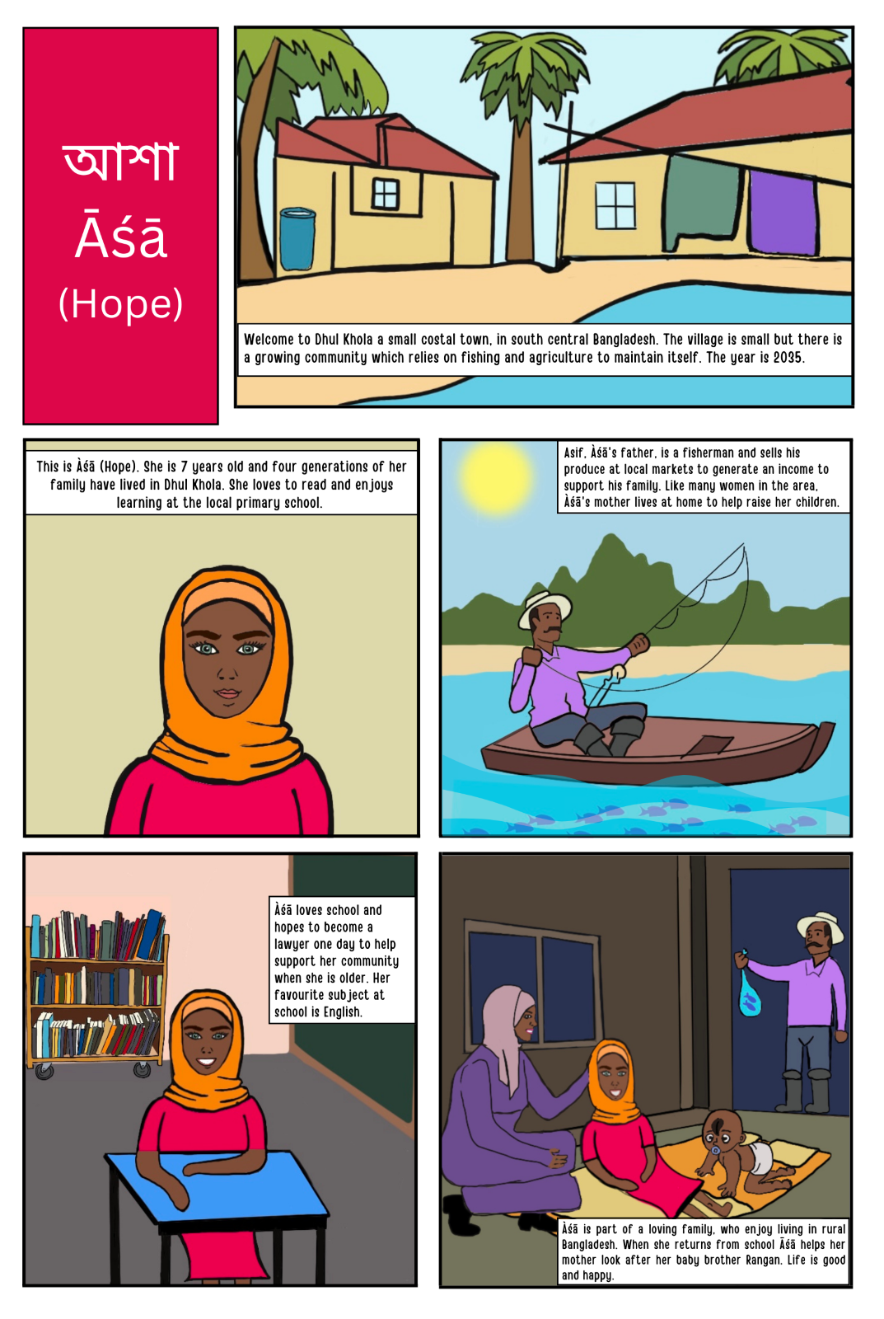
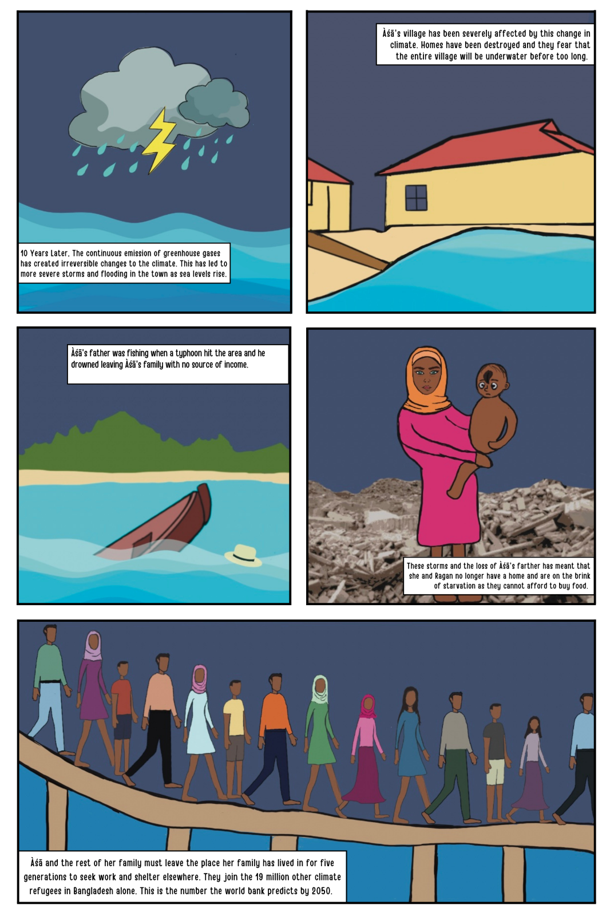
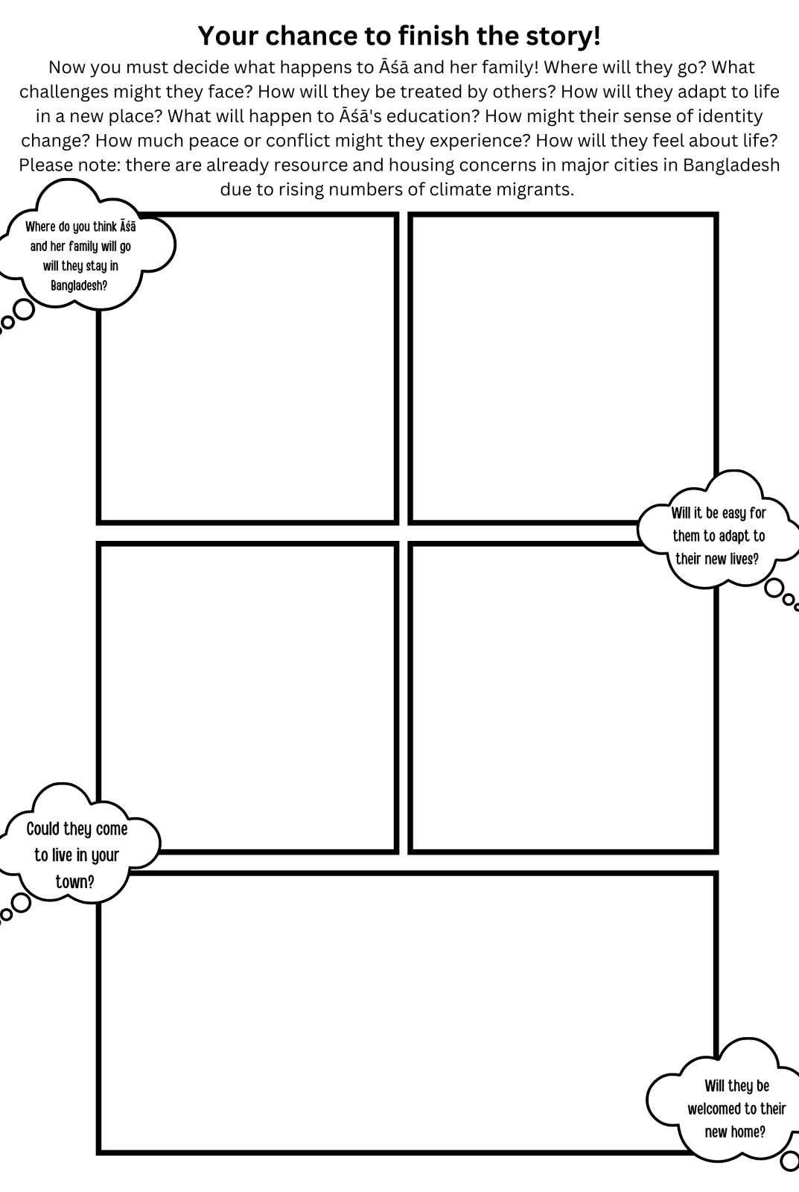

Surveys

Pre-session questions for students

I know a lot about the impacts of climate change. Rate 1 (Strongly Disagree) to 5 (Strongly Agree)
 | 1 | 2 | 3 | 4 | 5
 | o | o | o | o | o

I know a lot about climate migration. Rate 1 (Strongly Disagree) to 5 (Strongly Agree)
 | 1 | 2 | 3 | 4 | 5
 | o | o | o | o | o

I care about climate refugees. Rate 1 (Strongly Disagree) to 5 (Strongly Agree)
 | 1 | 2 | 3 | 4 | 5
 | o | o | o | o | o

I think climate migration is an important topic which most people should learn about. Rate 1 (Strongly Disagree) to 5 (Strongly Agree)
 | 1 | 2 | 3 | 4 | 5
 | o | o | o | o | o

I learn about important topics like climate change, war and peace from different forms of media like
- Fiction books
- Fact books
- Comics/graphic Novels
- TV programmes
- Films
- News reports
- Newspapers
- School

Post-session questions for students

I now know more about the impact climate change Rate 1 (Strongly Disagree) to 5 (Strongly Agree)
 | 1 | 2 | 3 | 4 | 5
 | o | o | o | o | o

I now know more about climate migration. Rate 1 (Strongly Disagree) to 5 (Strongly Agree)
 | 1 | 2 | 3 | 4 | 5
 | o | o | o | o | o

After learning more about climate migration, I care more about what happens to climate refugees. Rate 1 (Strongly Disagree) to 5 (Strongly Agree)
 | 1 | 2 | 3 | 4 | 5
 | o | o | o | o | o

I think climate migration is an important topic which most people should learn about. Rate 1 (Strongly Disagree) to 5 (Strongly Agree)
 | 1 | 2 | 3 | 4 | 5
 | o | o | o | o | o

I think comics are a good way to learn about important topics like climate change, war and peace. Rate 1 (Strongly Disagree) to 5 (Strongly Agree)
 | 1 | 2 | 3 | 4 | 5
 | o | o | o | o | o

I enjoyed learning about climate migration through this comic. Rate 1 (Strongly Disagree) to 5 (Strongly Agree)
 | 1 | 2 | 3 | 4 | 5
 | o | o | o | o | o

In the future I would like to learn about more peace topics through comics like the one I just read. Rate 1 (Strongly Disagree) to 5 (Strongly Agree)
 | 1 | 2 | 3 | 4 | 5
 | o | o | o | o | o

Teacher Survey

The students in my class enjoyed using the comic to learn about climate migration. Rate 1 (Strongly Disagree) to 5 (Strongly Agree)
 | 1 strongly disagree | 2 | 3 neither agree or disagree | 4 | 5 Strongly agree
Click to write Statement 1

The students in my class had a strong understanding of climate migration prior to the session. Rate 1 (Strongly Disagree) to 5 (Strongly Agree)
 | 1 strongly disagree | 2 | 3 neither agree or disagree | 4 | 5 Strongly agree
Click to write Statement 1

The students in my class learnt new things about climate migration as a result of the comic workshop. Rate 1 (Strongly Disagree) to 5 (Strongly Agree)
 | 1 strongly disagree | 2 | 3 neither agree or disagree | 4 | 5 Strongly agree
Click to write Statement 1

Can you write down some key takeaways which your students took from the session?
________________________________________________________________

What did your students enjoy about working with the comic?
________________________________________________________________

Is there anything about the comic workshop which you think could be improved?
________________________________________________________________

Would you describe this comic workshop as an example of ‘peace education'? Rate 1 (Strongly Disagree) to 5 (Strongly Agree)
 | 1 strongly disagree | 2 | 3 neither agree or disagree | 4 | 5 Strongly agree
Click to write Statement 1

What subject area(s) do you see it best fitting into in a school setting?
________________________________________________________________

What different media do you use to teach students about important topics like climate change, war and peace?
________________________________________________________________

Would you welcome more workshops and teaching materials like this to teach challenging topics like climate change, war and peace? ( Rate 1 (Strongly Disagree) to 5 (Strongly Agree)
 | 1 strongly disagree | 2 | 3 neither agree or disagree | 4 | 5 Strongly agree
Click to write Statement 1

Thank you very much for engaging with our resources and contributing to our project!

If you would like to be kept informed about our work, please include your contact details below:

––––––––––––––––––––––––––––––––––––––––––––––––––––––––––––
Extra links to further resources

Museum entry- Comic

Background to Shujaaz and podcast

Citations

Allport, G. (1954). The Nature of Prejudice. Reading: MA: The nature of prejudice.

Charlemagne (2022) A new migration crisis is brewing in Europe, The Economist. The Economist Newspaper. Available at: https://www.economist.com/europe/2022/11/17/a-new-migration-crisis-is-brewing-in-europe (Accessed: November 19, 2022).

Harris , I.M. (2004) “Peace education theory,” Journal of Peace Education, 1(1), pp. 5–20. Available at: https://doi.org/10.1080/1740020032000178276.

IEP (2020) Institute for Economics and peace – analysing peace and quantifying its economic value, Institute for Economics and Peace Home Comments. Available at: https://www.economicsandpeace.org/ (Accessed: November 16, 2022).

MacDougall, D. (2022) The UK isn't alone, Denmark also wants to fly asylum seekers to Rwanda, euronews. Available at: https://www.euronews.com/my-europe/2022/10/10/denmark-election-parties-on-left-and-right-back-controversial-plan-to-send-asylum-seekers- (Accessed: November 17, 2022)

Merrick, R. (2022) “UK human rights record and Rwanda deportation plan attacked at UN review,” The Independent, 10 November. Available at: https://www.independent.co.uk/news/uk/politics/human-rights-rwanda-asylum-seekers-b2222246.html (Accessed: November 17, 2022)

Paluck, E.L. (2009) “Reducing intergroup prejudice and conflict using the media: A field experiment in Rwanda.,” Journal of Personality and Social Psychology, 96(3), pp. 574–587. Available at: https://doi.org/10.1037/a0011989.

Peace, S. (2021) The importance of peace education, à propos. Available at: https://www.swisspeace.ch/apropos/the-importance-of-peace-education/ (Accessed: October 24, 2022).

Yamshon, E. and Yamshon, D. (2006) Comics Media in Conflict Resolution Programs: Are They Effective in Promoting and Sustaining Peace?, Redirecting... Available at: https://heinonline.org/HOL/Page?collection=journals&handle=hein.journals%2Fhaneg11&id=425&men_tab=srchresults (Accessed: November 19, 2022).

Wagner, N. (2020) Soft sell advertising: What it is, why it works, and how to execute, Stevens & Tate Marketing. Nicole Wagner https://stevens-tate.com/wp-content/uploads/STLogo-websml-biggerAM.png. Available at: https://stevens-tate.com/articles/soft-sell-advertising-what-it-is-why-it-works-and-how-to-execute/ (Accessed: November 5, 2022).
2021
Winner: Sid Ramachandran
Proposal:
Ameliorating Food Insecurity with the MIDAS Touch
Two summers ago, as the pandemic was raging in our state of New Jersey, I realized that the workers at the Trenton Soup Kitchen (TASK) were struggling to manage the influx of in-kind donations from the community. I have been going to the soup kitchen since I was seven and know that many of the dedicated service men and women working there were risking their lives to support the community. With a meteoric increase in the number of people facing food insecurity came the challenge of efficiently managing the donations and distributing them. With my interest in computer science, I created MIDAS, a donation acknowledgement software, to address these challenges. Initially, it was meant to be a simple Google Form that captured the items donated along with basic donor contact information. But given the CDC’s 2020 advisory to remain contactless, the project expanded into a cloud-based app that allows donors to fill, print, label, and track their in-kind donations and receive online receipts as soon as the items are scanned at the charities. The appeal for donors included touch-free delivery, tax deductions and lower disposal costs. Utilizing my HTML and JavaScript knowledge, I quickly prototyped the screens and sought feedback from social workers before subscribing to a server and setting forth on my .NET and SQL exploration. I created a transaction and queue management table to track the submissions and triggered notifications to the approvers so that donors can simply drop off labelled boxes with barcodes, which can then be scanned and processed automatically. Thank You letters were templated with a combination of static and dynamic content and authorized electronic signatures embedded into the letters to make the end-to-end transaction completely contactless.
In addition to improved safety and efficiency, accountability and valuation for the in-kind donations also increased as all the individual items were tracked and automatically reconciled. Weekly, monthly, and yearly analytical reports using denormalized STAR schema (a flat database structure) presented demographic and seasonal trends to anticipate and manage shortfalls. As the soup kitchen started using MIDAS, other local organizations also expressed interest in using the app, so I segregated data and access based on entitlements to support multi-tenancy. The platform, now scalable to several thousand users, has features to allow inventory management and collaboration. I am now working to expand the donor base to include local grocery stores, farms, and restaurants to donate their surplus, unplaced, expired “sell-by”, and cosmetically damaged items through this app. With the network of volunteers already in place to safely pack and ship the items that are within the guidelines of the FDA and the Good Samaritan Food Donation Act, the volume of food donated through the app is rapidly growing.
MIDAS has numerous ties to my academic interests. For one, it shows the macroeconomic problems firms face (in this case, soup kitchens) face with their supply chain management. MIDAS is a perfect example of how technological advancement can ease difficulties in a business. There is also a deeply philosophical belief that drives TASK ,the notion that all human beings deserve a warm meal. I share this altruistic bent of mind and strongly feel it is the role of technological innovation and advancement to aid noble motives. It is my dream to bring this software to the local parts of Scotland and to potentially create new applications which are tailored specifically to their concerns. Creating MIDAS and seeing it mature into an efficient and simple marvel of technology has bolstered my faith in the power of innovation. Furthermore, the scale of solutions like MIDAS illustrate that even major problems in my community, a diverse mix of wealth and poverty contained in just ten square miles, can be alleviated over time, by people like me.
While MIDAS started off as a small-scale project to support my local soup kitchen, it soon blossomed into a technological, community, and personal achievement. A few lines of code innovated TASK’s procedures to better protect and serve countless patrons. This experience has shown me society’s and my own capacity for innovation and contribution to the realm of food donation. In addition to MIDAS’s noteworthy utility during the pandemic, this software had the effect of motivating me further to push ahead and uncover the unseen. MIDAS was the first project that made me feel like a student, teacher, neighbour, patron, and entrepreneur all at once. I lookback on it and believe in my ability to apply myself to the betterment of our future in a changing world. While the experience gave me the confidence to solve problems and serve the greater good, food insecurity is still a rising problem, exacerbated by the pandemic. With our national average for food waste at 30-40%, millions of dollars’ worth of food is wasted by every community. Spreading this food-saving an food donation initiative to neighbouring counties and states is the next step to chew at this problem one bite at a time. Link: http://midasapp.feat4ever.org/Home/Registrationhttp://www.feat4ever.org/
2020
Winner: Deanna Coleman
Module/ School: Post-Soviet International Relations of Central and Eastern Europe, School of International Relations
Proposal:
The St Andrews Forest Proposal
The proposal for a carbon offsetting project for unavoidable travel emissions to and from our small town on the East Fife coast – come to be known as the St Andrews Forest – was originally inspired by module in International Relations. Taught by Dr Marat Iliyasov, The Post-Soviet International Relations of Central and Eastern Europe may seem like a far stretch to a project on carbon management, but poses more links than what meets the eye.
The focus of the final two weeks centred around the relationship that these post-communist states held with the European Union (EU) and the wider international setting. A particular tutorial took me beyond the required readings when we were asked to critique a certain article on the subject. In an attempt to put my own spin on it, by applying their relationships as a case study to my passion, the environment, I looked at how the EU Emissions Trading Scheme works with the states in question. Evidently, all 27 states of the EU are involved in the scheme as well as Iceland, Liechtenstein and Norway. I compared this to what could be on offer for those ex-satellite states that were not a part of the EU - the United Nations’ REDD+. The research for the module ended here, but, I couldn’t help notice a repetition: the compliance market.
The completion of the module allowed me to carry out my own investigation and question what options would be available to businesses in states that are not mandated to be a part of the compliance market. It was then that I realised there was no form of regulation for the voluntary market. I saw a gap and I became determined to change that.
Bringing this research closer to home, I explored St Andrews’ relationship with carbon offsetting, and the results were conclusive: the chaos and under-regulation of a voluntary carbon offsetting market. My further investigation explored how this sentiment was shared across business and all other UK universities.
After an entire proposal and a number of discussions with the ESB, as well as student consultation, the St Andrews Forest idea was born. The summer of 2020 was filled with numerous meetings with field-distinguished professionals, and specific data collection with the Estates Team. Thus, the proposal was extensive and featured three key channels (objectives) separated into six workstreams.
The first objective of the St Andrews Forest proposal was the creation of the forest itself. Requiring a size of Tentsmuir Forest for just one year of offsets was an area that would be difficult to locate in Fife. The most tangible, and thus potentially most engaging suggestion was to split the Forest into a series of smaller ones that could be found in different farms around the town. The second location looked at brownfield regeneration which involved the deconstruction of an ex-power plant in western Fife, a symbolic but perhaps restrictive innovation. The last were a series of invitations to plant this potential forest (including room for future growth) in the land of various wealthy landowners across Scotland, such as Alladale. While this suggestion was popular, it would be rendered null unless St Andrews could responsibly verify these voluntary offsets.
The second objection was specifically a focus on voluntary offsets. The paper called for further research into creating a system across Scotland that could regulate voluntary offsets, pinning the nation as a carbon broker. This would be a huge step for the University and allow them to be the face of this new regulation that could potentially extend beyond use at solely St Andrews. This investigation could be left as a research proposal for students.
The research proposal to consider how St Andrews could become the face of voluntary offsetting could be left at the hands of the students. The students were deemed pivotal to the success of the Forest as the future leaders in environmental action and creators of their own destiny in this race for environmental change. Therefore, the third objective centered around the creation of modules across all disciplines that allowed any student to be involved with the forest: from Geography, whereby students have physical input, to Management students, who steer the community relations.
Reflection on this latter objective has changed the various modules to one Vertically Integrated Project (VIP), commencing January 2022. Led by Dr William Austin, students from all disciplines would have the opportunity to be involved in a unique research experience centred around the St Andrews Forest. In the form of a CEED workshop series beginning this semester, students will be a part of a series of carbon capture workshops led by field-leading experts. Thus far, the positive response has been overwhelming. Moreover, this particular aspect is in line with the ESB’s participation in the Global University Climate Forum, which means that upon successful completion, it could be showcased at COP26.
Experts believe an entrepreneur should fall in love with the problem, not just the solution. Writing the St Andrews Forest proposal has ignited this feeling; I have enjoyed the process. Bringing together skills, from strategic planning to balancing intuition with rationality, and consistently reflecting and re-evaluating to ensure the professionality of the task has been treacherous, yet incredibly rewarding.
When presenting this proposal to the Environmental Sustainability Board (ESB), Professor Sir Ian Boyd saw its immediate potential, probing “do we all agree this should be sent straight to the Principal?”. The Principal highly commended this entrepreneurial proficiency. How about you?
Please visit the project website for more information!

2019
Winners: Alexandra Stephenson and Zoe Berkeley
Module/School: AH2002 Art, Culture and Politics from 1900 to Now, School of Art History
Proposal:
Alternative Art Histories
In April of 2019, we co-founded Alternative Art Histories, a lecture series that aims to respond to the issues raised by lecturers in AH2002 Art, Culture and Politics from 1900 to Now, regarding how, as historians, we mediate and respond to the changing direction of Art Historical practice. We are both students engaged with the debate surrounding the diversification of the curriculum in and outside of class, having regularly attended Athena Swan and Equality, Diversity and Inclusion meetings. We felt that there was interest in the St Andrews community for a curriculum to highlight art that is usually excluded from or marginalised within the Western canon of Art History. In AH2002 Art, Culture and Practice from 1900 to Now, we discussed how the Western canon frequently dominates the teaching and perception of the subject and the pressing need to diversify the canon and explore Art History’s relevance to current issues. It remains a challenge to incorporate this material into the current structures of the Art History department, thus ‘Alternative Art Histories’ aims to provide the platform for change by calling attention to alternative, under-represented art histories.
We have a programmed lecture series arranged that takes place in an informal pub setting to facilitate an interactive, discursive environment and to promote the accessibility of Art History for everyone. Lectures are free to attend, last approximately 30-40 mins in length, and are followed by a Q&A discussion with the speaker. Since beginning the lecture series in April 2019, we have begun hosting the lectures on a monthly basis, and the below list details the lecturers and topics that have been featured:
Dr Jeremey Howard, April 2019 - Firing the Canon, Questioning the Forces: Broaching the Boundaries of (West) Europeanist Art History
Dr Camilla Mork-Rostvik, September 2019 – The Painters Are In’: The Visual Culture of Menstruation since 1970
Dr Alistair Rider, October 2019 – Doing Art History in the Age of Climate Emergency
Dr Natalia Sassu Suarez Ferri, November 2019 – Kinetic Art in the Time of Political Migration: “Since they can’t put Venezuela in their suitcases, they take the mosaic tiles from the airport”
Dr Marika Knowles, February 2020 – Makeup & #MeToo: Feminism and Art History
Upcoming:
Dr Luke Gartlan, March 2020 – Japan (title tbc)
Dr Kate Cowcher, April 2020 – African European collections (title tbc)
We have been overwhelmed with the response from both students and the department of Art History to the Alternative Art Histories series. Our most recent event, hosted in February with Dr Marika Knowles, attracted over 350 interested participants on our Facebook event. Every one of our lectures has been well attended, and the feedback from students is unanimously positive – demonstrating the demand for curriculum change in St Andrews.
Currently, we can only host speakers from the University of St Andrews department of Art History who speak on a volunteer basis. With funding from the award, we could put this towards inviting external speakers to travel to St Andrews, bringing new and diverse voices to our university town and pushing us further towards our goal of diversifying art historical teaching and practice.
We have attached some of the event graphics which we created for the production and marketing of our lecture series. We hope that these give you a sense of the creativity and atmosphere of innovation that we hope the lectures foster. Thank you for your time and we hope that our joint application with Alternative Art Histories will be considered for the Enterprising Mind of the Year Award 2019/20.

2018
Winners: Morganne Wilbourne and Izzy Dunstan
Module/School: BL2309 Applied Molecular Biology, School of Biology
Proposal:
St Andrews iGEM Team
Last year, based on the BL2309 Applied Molecular Biology module, we revived the St Andrews iGEM team, a group of students who competed in a synthetic biology project over the summer of 2018. In the spring semester, Dr. Anne Smith gave a short lecture series covering topics in synthetic biology for the Applied Molecular Biology module. She taught us about the ways in which synthetic biology incorporates the principles of engineering into biology, including the importance of standardized genetic parts and a design, test, revise cycle. Following her lessons, we recruited a team and extended the material Dr. Smith taught us to compete in iGEM.
iGEM is essentially a genetic engineering competition aimed at undergraduate students, and we had heard of it in March, just before Dr. Smith gave her lectures. We wanted to participate, but didn’t know where to start, and Dr. Smith’s experience with synthetic biology made her an obvious member of staff to contact. She’d supervised iGEM teams before, the last time being in 2012, and had the experience we needed to get started. On the other hand, we had the drive and the passion to recruit a team of fellow undergraduates, all before the final registration deadline at the end of April. When all was said and done, we had raised more than 20,000 pounds, recruited nearly 20 students to work on the project, and convinced a total of 6 members of staff to help supervise.
While we were planning the initial stages of the project, the team considered ideas and proposals from several of the members, and then challenged and critically analysed the concepts so that our final idea satisfied each of the project requirements to earn a medal in the iGEM competition. In the end, our team built upon the information Dr. Smith presented during her lectures to create a system which tested the effectiveness of potential lead compounds for antibiotic development. The crux of the project relied on a protein which glowed when cells died, and we also explored ways to detect the formation of biofilms—sticky scaffolding that some bacteria use to colonize their hosts.

In October, the team traveled to Boston to attend the culminating conference for iGEM, where we earned a bronze medal. This year, we have already selected the new team and begun raising funds for our next project. We intend to take what we learned, both from the Applied Molecular Biology module and from our experience competing last year, to complete all of the competition requirements and take home a gold medal next fall. It’s been an incredibly instructive exercise for us to evaluate the things we accomplished last year so that we can more effectively help this year’s team plan and execute an even more complex project. Over all though, iGEM has been an amazing experience for us, and we’re excited to continue developing the team infrastructure so that many years of students to come may participate.

